

1

Maths Curriculum
Go-To Guide:
KS3
Unit: Number Structures
Topic: Place Value
Creative Education Trust

Contents
Overview 3
NC Objectives 3
Summary 3
Where in the Curriculum 3
Past Curriculum Links 3
Upcoming Curriculum Links 3
Cross-Curricular Links 3
Topic Familiarisation 4
Questions 4
Mark Scheme 4
Examiners Notes (Where Available) 4
Possible Models and Tips 5
Key Words 6
Tier 3 Vocabulary 6
Tier 2 Vocabulary 6
Topic History and Hinterland 7
Possible Learning Sequence 8
Misconceptions 9
Resources 10

Overview

NC Objectives
- understand and use place value for measures and integers
- order positive and negative integers
- use the number line as a model for ordering of numbers
- use the symbols =, ≠, <, >, ≤, ≥

Summary
The content covered here is all about the basic understanding of our Hindu-Arabic number system. This topic is limited to integers only - all whole numbers (positive, negative and zero). Students should be able to understand our place value system, the relative sizes of these and how number lines can be used represent the relative position of numbers.

Where in the Curriculum
This content is one of the first units students will encounter in Year 7.

Past Curriculum Links
Whilst all of this content would have been explored at KS2, it is vital that all students master its content. An understanding of number at this level is crucial for future engagement in the course.

Upcoming Curriculum Links
It would be hard to find content coming up that does not in some way link to the content covered in this section.

Cross-Curricular Links
Any work that requires students to be numerate would depend on the concepts delivered in this unit.

Topic Familiarisation
This is an exercise for teachers to complete before teaching a unit to familiarise them with both the pedagogical and subject knowledge necessary to delivery this topic effectively. Teachers should seek to ensure they can confidently answer all these questions and understand the “why” behind each one before teaching the first lesson of a unit. It’s important to note that the questions are not an exhaustive list of how something can be assessed. Instead, they give an indication as to some of the ways in which the content can appear and teaching, at the very least, needs to prepare pupils for these.
Structure:
- Questions
- Mark scheme
- Examiner’s report – where available
When completing the questions, it is important to do more than just find the correct answer. Ask yourself:
- What might my students struggle with?
- What gaps are there in my subject knowledge?
- What do I want a model answer to look like?
- How do I know what to do for each question? What are the clues?
- What do the examiner reports say are the main issues students have? How can I address these?
- What do the mark schemes look like? How can students achieve full or partial marks?
- What alternative methods are available? Will this affect how I model these processes?
- Are there links to other subjects? What chances do I have to make this explicit?
- What pre-requisite knowledge will my students need? How can I deliver this?

Questions
Q1.
Join each abacus to the number it shows. One is done for you.
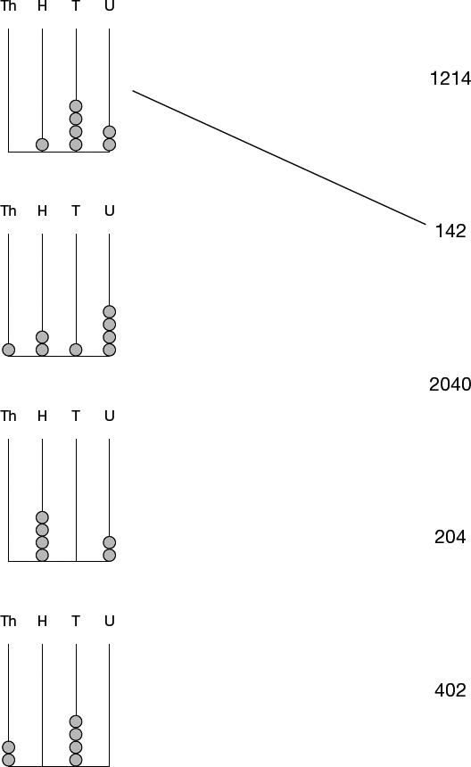
[2 marks]
Q2.
The ancient Egyptians used pictures to show numbers.
The table gives some of these pictures.

Number | Picture
one
ten | 
one hundred | 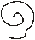
one thousand | 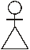
Write in figures the number that each picture below is showing.
The first one is done for you.
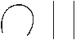 _______12_______
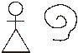 _________________
[1 mark]
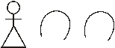 __________________
[1 mark]

Q3.
Circle the number which is closer to 1000
996 1006
Explain how you know.
_______________________________________________________________________
_______________________________________________________________________
[1 mark]
Q4.
The diagram shows part of a number grid.
Fill in the missing numbers.
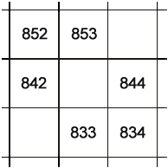
[1 mark]
Q5.
(a) In the number 4378, the ﬁgure 7 represents 7 tens.
What does the ﬁgure 3 represent?
___________________________________________________________________
___________________________________________________________________
Answer _________________________________________
What does the ﬁgure 4 represent?
___________________________________________________________________
___________________________________________________________________
Answer _________________________________________
[1 mark]
(b) Write in ﬁgures the number twenty thousand and twenty.
Answer _________________________________________
[1 mark]
Q6.
(a) Look at the scales.
What is the mass of the chick?
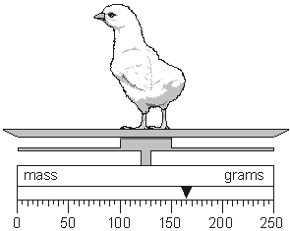
Answer ____________________________________ grams
[1 mark]
(b) The diagram below shows the same chick on different scales.
Draw an arrow to show the mass of the chick.
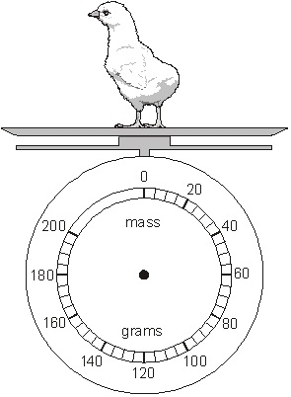
[1 mark]

Q7.

The arrow by this thermometer shows a temperature of 20°C  (a) Draw an arrow by the thermometer to show a temperature of –8°C  (b) The temperature was –10°C  It went up by 15°C  What is the new temperature?  _________________ °C | 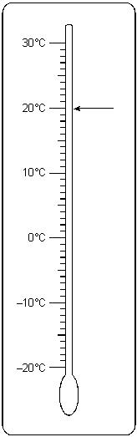 | [1 mark]  [1 mark]
(c) Write these temperatures in order, starting with the coldest.
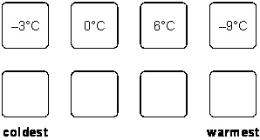
[1 mark]

Q8.
(a) Look at this scale.
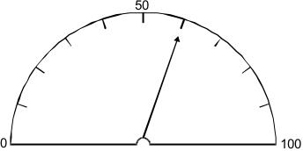
What value is the arrow pointing to on the scale?
Answer _________________________________________
[1 mark]
(b) Here is a different scale.
Draw an arrow (↓) so that it shows the same value as the arrow in part (a).
[1 mark]

Mark Scheme
Q1.
Matches each abacus to its correct number, ie
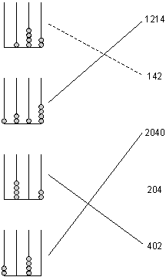
2
or Makes two correct matches
1
Accept unambiguous indication
Do not accept abacus matched to more than one number
For 2m or 1m, do not accept as a correct match
[2]
Q2.
1100
1
! Responses given in words
Penalise only the first occurrence
1020
1
[2]
Q3.
996 circled, and an explanation that it is closer in value than 1006 to 1000, eg:
• ‘996 is 4 less than 1000, but 1006 is 6 more’
• ‘1000 – 996 = 4, 1006 – 1000 = 6’
• ‘It’s closer by 2’
•
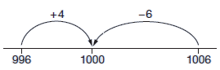
• ‘Both end in 6 which means to the nearest ten they round up. So 996 rounds up to 1000,
but 1006 rounds up to 1010’
• ‘1006 is nearer 1010, but 996 is nearer 1000’
• ‘996 is only 4 away’.
No mark is awarded for circling 996 alone.
Do not accept vague or incomplete explanations, eg:
• ‘1006 is further away’
• ‘996 is less than 1000, but it is still closer than 1006’
If 996 is not circled, but a correct, unambiguous explanation is given, then award the mark.
U1
[1]
Q4.
Gives all three correct values, ie
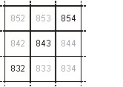
[1]
Q5.
(a) Gives both correct values in the correct order,
ie
3 hundred(s)
4 thousand(s)
Accept unambiguous indication
eg 300 or 4000
! Response fails to quantify the number of
hundreds and thousands
Condone
eg, accept, Hundred(s), Thousand(s), 100(s), 1000(s)
Do not accept ambiguous spelling
eg, for hundred
• hundredth
• hundreth
1
(b) 20 020
Do not accept response given in words
1
[2]
Q6.
(a) 165
1
(b) Indicates 165 on the scale, ie
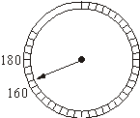
! Follow through from part (a)
Accept provided their (a) is not a multiple of 10
! Inaccurate indication
Accept provided the pupil’s intention is clear
eg, for 165 accept
• Their indication is closer to 165 than to either 160 or 170
eg, for follow through from 153 accept
• Their indication is between 150 and 155
! Arrow or line too shor - Markers can extend to check accuracy
1
[2]
Q7.
(a) Indicates –8 on the thermometer
! Indication not accurate
Accept, provided it is closer to –8 than to –9 or –7
1
(b) 5
1
(c) Orders correctly, ie
–9°C –3°C 0°C 6°C
Accept unambiguous indication, eg
• 4th, 1st, 2nd, 3rd
Units omitted or incorrect - Ignore
1
[3]
Q8.
(a) 60
Accept value between 59 and 61 inclusive
Units give - Ignore
1
(b) Indicates the correct position, eg
•
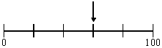
Accept unambiguous indication, eg
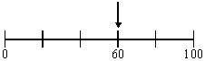
! Follow through
Accept follow through from part (a), provided their (a) is not 0, 50 or 100
! Position not indicated accurately
Accept within ±2mm
1
[2]

Examiners Notes (Where Available)
Q8.
Scales
Target Level: 3
This report refers to pupils awarded an overall level that is the same as the target level for this question unless otherwise stated.
Curriculum Coverage (POS ref: KS2/Ma3/4b)
In this question pupils are required to read a value on a scale graduated in tens and show this same value on a scale graduated in twenties.
Performance
Nearly all pupils answered part (a) correctly and over half of pupils answered part (b) correctly.
Common errors and misconceptions
(a) About 5% of pupils misread the scale and gave 55.
(b) Over 10% of pupils drew an arrow indicating 50 implying that pupils reproduced the number given on the scale from part (a) rather than indicating the position of the arrow. Alternatively, they may have followed through from an incorrect reading of 50 in part (a).
Facility values
 | Tier 3 – 5
 | L3 | L4 | L5
a | 0.94 | 0.97 | 0.98
b | 0.56 | 0.82 | 0.92

Possible Models and Tips
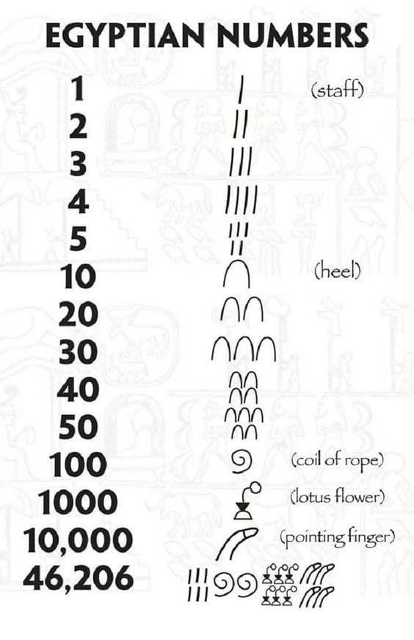
This section will give an overview of some models, layouts, metaphors, misconceptions, or just general tips that could be used to help teach parts of this unit.

Compare and Contrast – Numeral Systems
Our place value system can feel so intuitive that it’s hard to imagine other ways to represent numbers. The majority of civilisations however have not used this system and to assume it is intuitive may hinder students who have not fully understood how our Hindu-Arabic number system works. One way to help show the mechanics and strengths of this, now global system, is to compare and contrast it with other options.
Unary number systems – simply a mark for each value, similar to a tally or counting on fingers, 1, 11, 111, 1111, 11111…
Sign value notation – different symbols represent different amounts and repetitions of these symbols represent multiples of this amount. The Ancient: Egyptian, Roman Mayan, Babylonian, Greek, Chinese… the list goes on.
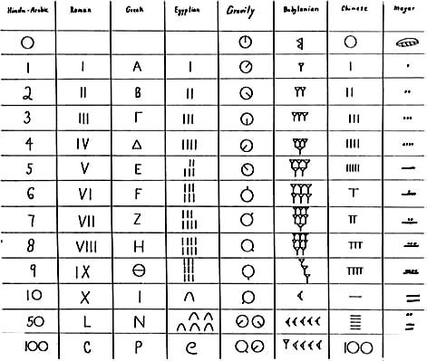
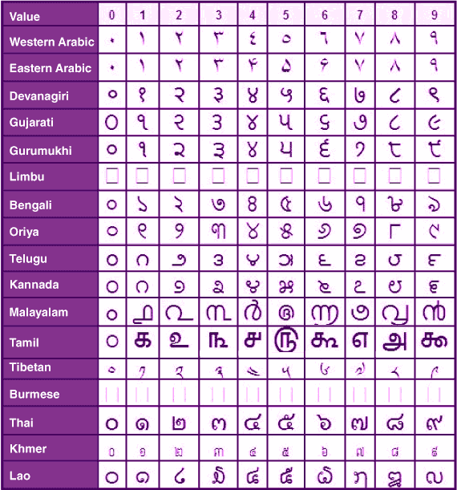
Place value – the Babylonians (now modern-day Iraq) were the first to use a place value system, similar to what we use today. They had no notation for zero and although spaces could be used differentiating between numbers like 110, 11, 1, 100, 101 it was tricky (worth noting here they used base 60 so the value of these numbers wouldn’t necessarily have been a problem). Later, through China and India a 0 was added meaning that numbers could be uniquely presented and easily distinguished. This came to be known as the Hindu-Arabic number system and formed the basis of the number system most of the world uses today.

The Numerals
Something worth exploring is the different ways that civilisations have represented those first few numbers. The common use of a single line for a “1” may or may not have come from the representations of a single finger. The ways ideas have progressed over the world to arrive at the numbers we know today represented what a global endeavour mathematics has been historically.

A Note on Roman Numerals
Whilst it is commonly believed that certain Roman numerals required subtraction operation, e.g. 4 represented as IV (5-1), it was not uncommon for it to be represented as IIII. There are many examples of 9 being both IX or VIIII in historical contexts.

Compare and Contrast – Different Bases
The most common number system students are exposed to is a base-10 system. This means that once you have ten of a value, it is equivalent to one of the next place value column e.g. ten ones is the same as one ten, ten tens is the same as one hundred… Forcing students to work in different bases can help them see the characteristics of base-10 even more clearly.
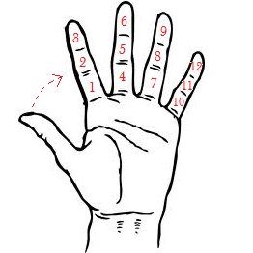
This is not the only base people use though and it is worth letting students know that there is a certain arbitrariness to using ten, despite how natural it seems to people that grow up with that all around them.
Our timekeeping has elements of the Babylonian base 60 system, i.e. every 60-seconds is 1 minute, every 60-minutes is 1 hour. Whilst our current base-10 most likely comes from counting on our hands it is worth noting that it is relatively simple to count to 12 on one hand as well using your thumb and the bones in your hand. If you then chose to show a different finger on your other hand for each of the 12 combinations you can have 60 different ways of representing values and thus a base-60 system can be shown using just 2 hands.

Our computing software often utilises base 2 (binary), as electronics can sometimes only interpret things as “on” or “off” leading to 0s and 1s being used. The “standby” button most people are familiar with represents this by being a 1 placed within a 0.
Students studying French may recognise the language of their number system, although written digitally in base-10, uses the language of their old base-20 system. Their 80 for example not coming from “eight-tens” but written as “quatre-vingt”, meaning four twenties.

Exploding Dots
A nice introduction to different base systems for students can be James Tanton’s Exploding Dots https://www.youtube.com/watch?v=IMsSeplZ8hg

Arithmetic
Having students do arithmetic using the systems from other civilisations can be a good activity to help reinforce what is actually happening when they follow the formal process they probably know so well in the Hindu-Arabic number system.

Key Words

Tier 3 Vocabulary
This vocabulary will be specific to maths and will need explicitly teaching to students.
Word | Definition
Integer | A whole number, including 0 and negatives
Place-value | A number system where the same numeral can represent different quantities depending on its position

Tier 2 Vocabulary
This vocabulary will not be specific to maths but may have a different meaning or usage in the maths classroom to what students are used to. These words will likely not need introducing to the students but the way they are used in a maths context may.
Word | Definition
Base | General - The structure on which something depends (from here links to its use in Maths, art, sport, languages etc can be derived)  Chemistry – A substance capable of reacting with an acid to form a salt and water
Base-10 | A number system where each column represents ten of the previous one
Binary | Maths - A place value number system using base-2  General – relating to, composed of, or involving two things
Numeral | The symbol used to represent a number
Digit | Maths - A symbol used to represent a number (7 is a digit in the number 74)  Biology – a finger, thumb, or toe (a link here to counting, the maths term comes from the biology term, not the other way round)

Topic History and Hinterland
See “Model and Tips” section as these two sections are so intertwined for this topic.

Possible Learning Sequence
This gives a suggestion of the order in which content could be introduced to students when they are being taught this unit. These are not given as a list of discrete lessons but more a logical order which could lead to the strongest learning outcomes. It is assumed that any pre-requisite knowledge needed for the content in this unit has been adequately covered, these will only cover the order of the new content being introduced. Appropriate AO2 and AO3 aims should interwoven throughout the lessons students have – this is only a list of the knowledge content.
Order | Learning Outcome
1 | Appreciating number systems around the world
2 | What are the benefits of our number system?
3 | Representing numbers on a number line (various representations)
4 | Ordering negative numbers
5 | Using symbolic notation for ordering and equality

Resources
Find below a list of resources specific to this topic and some websites known to be good sources of general questions. Resources chosen are ones which put the maths front and centre. They make sure that what children are attending to is as beneficial to their learning as possible. Examples of things that would not do this are codebreakers and treasure hunt where the task itself may distract from the mathematics being studied. Maths classrooms need not (and in fact should not) be devoid of fun, surprise, and enjoyment but the maths being studied is complex and intriguing enough to be the fuel for this, we need not trick students into enjoying maths through any other route than the maths itself.
Resource | Sub-topic | Notes
Exploding dots | Place value/bases | Subscription needed but an internet search of “Exploding Dots” reveals lots of free-to-access resources and videos
History of Number | Place value | Brief overview of number systems

Generic Websites
https://variationtheory.com/ - sequences of questions where one small part of a question will change each time which can be used to encourage students to find and predict patterns with the aim of better understanding the underlying structure of the mathematics.
https://ssddproblems.com/ - SSDD problems are a special type of problem based on the observation from Roher, Dedrick and Burgess (2014) that the correct solution to most mathematical problems involves two steps: identify the strategy needed to solve the problem, and then successfully carry out that strategy. These problems help students with that first step by showing questions with a similar surface but a different depth difference. This makes method selection an explicit skill students will be able to practice.
https://www.mathsgenie.co.uk/gcse.html - a selection of past GCSE questions and exam-style questions grouped by topic and broadly by grade.
https://corbettmaths.com/contents/ - questions grouped by topic containing mixed practice and typically some AO2 or AO3 style questions as well.
https://nrich.maths.org/ - a source of richer problem-solving questions. To be used cautiously!
https://www.cimt.org.uk/ - an old and hard to navigate website full of great resources.
https://www.exampro.co.uk/ - AQAs bank of KS3 and KS4 assessment questions. These are up to date and can be filtered by key stage, tier, AO1/2/3, calc or non-calc, curriculum area….
http://www.mrbartonmaths.com/teachers/rich-tasks/standards-units.html - Standards Units - a relatively small collection of some great tasks.
https://assets.publishing.service.gov.uk/government/uploads/system/uploads/attachment_data/file/1056795/KS3_NonStatutory_Guidance_Sept_2021_FINAL_NCETM.pdf - Guidance from the NCETM and DfE about resources to be used at KS3.
https://www.geogebra.org/materials?lang=en – A searchable database of pre-made and dynamic resources using GeoGebra (sometimes best to search for the topic and include the word GeoGebra in Google to find what you want)
https://mathigon.org/ - an online textbook full of dynamic examples and mathematical history

