

1

Maths Curriculum
Go-To Guide:
KS3
Unit: Quadratics
Topic: Quadratics and Graphs
Creative Education Trust

Contents
Overview 3
NC Objectives 3
Summary 3
Where in the Curriculum 3
Past Links in Maths 3
Upcoming Links for Maths 3
Cross-Curricular Links 3
Topic Familiarisation 4
Questions 5
Mark Scheme 8
Examiners Notes (Where Available) 10
Possible Models and Tips 11
Key Words 12
Tier 3 Vocabulary 12
Tier 2 Vocabulary 12
Topic History and Hinterland 13
Possible Learning Sequence 14
Resources 15

Overview

NC Objectives
- simplify and manipulate algebraic expressions to maintain equivalence by expanding products of two or more binomials
- recognise, sketch, and produce graphs of quadratic functions of one variable with appropriate scaling, using equations in x and y and the Cartesian plane
- use quadratic graphs to estimate values of y for given values of x and vice versa
- find approximate solutions to contextual problems from given graphs of a variety of functions, including piece-wise linear, exponential, and reciprocal graphs

Summary
Students will be working predominantly with quadratics in this unit but some other parts of the curriculum are covered here too through the link to graphs. They will need to be able to expand products of two or more binomials (note there is no need to factorise or solve quadratic equations at KS3). Graphically, they should be able to sketch and plot graphs of quadratic functions and recognise the various forms a parabola may take. Quadratic graphs should be used to estimate values of y for given values of x and vice versa – in this context students could start to solve or find approximate solutions to quadratic functions but they should be doing this in any other means. They should extend the ability to read graphs both algebraically but also in real life contexts to piece-wise linear graphs, exponential and reciprocal graphs.

Where in the Curriculum
First assessment window – Y9

Past Links in Maths
This unit links to the previous units on graphs and on manipulating algebraic expressions.

Upcoming Links for Maths
As well as being revisited at KS4 students will also be exposed to solving and factorising quadratics and everything that comes with that. When interpreting real life graphs pupils will also learn about what can be gleaned from calculating the gradient of a tangent to a curve or by calculating the area under the curve.

Cross-Curricular Links

Topic Familiarisation
This is an exercise for teachers to complete before teaching a unit to familiarise them with both the pedagogical and subject knowledge necessary to delivery this topic effectively. Teachers should seek to ensure they can confidently answer all these questions and understand the “why” behind each one before teaching the first lesson of a unit. It’s important to note that the questions are not an exhaustive list of how something can be assessed. Instead, they give an indication as to some of the ways in which the content can appear and teaching, at the very least, needs to prepare pupils for these.
Structure:
- Questions
- Mark scheme
- Examiner’s report – where available
When completing the questions, it is important to do more than just find the correct answer. Ask yourself:
- What might my students struggle with?
- What gaps are there in my subject knowledge?
- What do I want a model answer to look like?
- How do I know what to do for each question? What are the clues?
- What do the examiner reports say are the main issues students have? How can I address these?
- What do the mark schemes look like? How can students achieve full or partial marks?
- What alternative methods are available? Will this affect how I model these processes?
- Are there links to other subjects? What chances do I have to make this explicit?
- What pre-requisite knowledge will my students need? How can I deliver this?

Questions
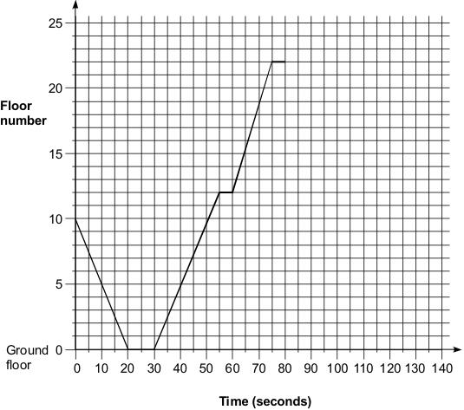
Q1.
The graph shows my journey in a lift.
I got in the lift at floor number 10

(a) The lift stopped at two different floors before I got to floor number 22
What floors were they?
___________________________________________________________________
___________________________________________________________________
floors _________________ and _________________
[1 mark]
(b) For how long was I in the lift while it was moving?
___________________________________________________________________
___________________________________________________________________
Answer __________________________________ seconds
[1 mark]
(c) After 1 got out of the lift at floor number 22, the lift went directly to the ground floor.
It took 45 seconds.
On the graph, show the journey of the lift from floor 22 to the ground floor.
[1 mark]
Q2.
A child is having a bath.
The simplified graph shows the depth of the water in the bath.
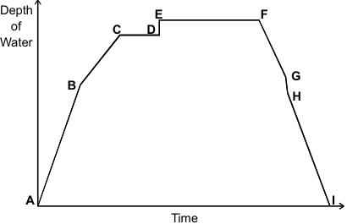
(a) From A to B both taps are turned full on.
What might be happening at point B?
___________________________________________________________________
___________________________________________________________________
[1 mark]
(b) Which part of the graph shows the child getting into the bath?
___________________________________________________________________
___________________________________________________________________
Answer _________________ to _________________
[1 mark]
(c) Which part of the graph shows the child getting out of the bath?
___________________________________________________________________
___________________________________________________________________
Answer _________________ to _________________
[1 mark]

Q3. Look at the expressions in the shaded boxes.
Draw lines to match them to the expressions on the right.
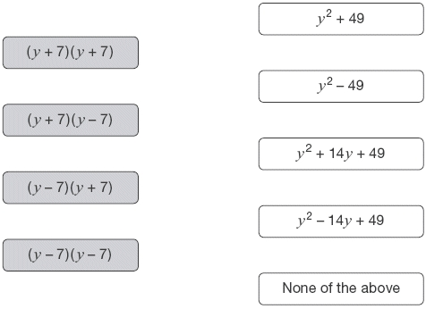
[2 marks]
Q4. Look at the right-angled triangle.
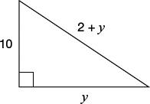
(a) Use Pythagoras’ theorem to complete the equation below.
(2 + y)² = _________________
[1 mark]
(b) Now work out the value of y
___________________________________________________________________
___________________________________________________________________
___________________________________________________________________
___________________________________________________________________
y = _________________________________________
[2 marks]
Q5.
(a) Complete the table of values for y = x² − 2x

x | −2 | −1 | 0 | 1 | 2 | 3
y | 8 | 3 |  |  | 0 | 3
[2 marks]
(b) Draw the graph of y = x² − 2x from x = −2 to x = 3
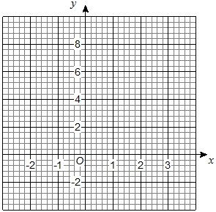
[2 marks]
(c) Write down the equation of the line of symmetry of the graph y = x² − 2x
Answer _________________________________________
[1 mark]
(d) Write down the coordinates of the minimum point of the graph of y = x² − 2x
Answer ( ________ , ________ )
[1 mark]

Mark Scheme
Q1.
(a) Ground floor (0) and 12, either order
1
(b) 60 ± 2
1
(c) a line from (80, 22) to ( 125, 0) that has no positive gradients.
Accept extends the horizontal line at floor 22 before descending provided the descent takes 45 seconds with no further stops.
Accept line from (75, 22) to (120, 0)
Accept line not ruled but intention clear
Accept parts of the line show acceleration and deceleration
1
[3]

Q2.
(a) States a possible reason for the reduced gradient, eg:
• The water is coming in more slowly.
• Hot tap off.
• Taps turning off.
• One tap on.
• Water pressure dropped.
• The water is running out.
• Its too hot so theyre putting cold water in.
• Bath gets wider.
• Plug starts leaking.
Do not accept responses which indicate no flow eg:
• ‘The taps are turned off.’
Do not accept a description of the graph eg:
• ‘It gets less steep.’
1
(b) Indicates D to E.
Accept E to D.
1
(c) Indicates G to H.
Accept H to G.
1
[3]
Q3.
Matches all four expressions correctly, ie
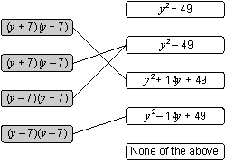
! Expressions on the left matched to more than one expression on the right
For 2m or 1m, do not accept as a correct match
2
or Matches at least two of the expressions correctly
1
[2]
Q4.
(a) Completes the equation correctly
eg
• y² + 10²
• 100 + y²
! (2 + y)² = 10² + y² seen, followed by incorrect working
Condone
1
(b) 24
2
or Shows or implies a correct expansion of (2 + y)² even if there
is incorrect or no further simplification
eg
• 4 + 4y + y²
• 2 × 2 + 2 × y + 2 × y + y × y
• y², 4y, 4
1
Accept correct expansion seen in part (a)
[3]
Q5.

(a) 0, −1
B1 for either
B2
(b) Their points plotted correctly
B1ft
Smooth curve through their points
B1ft
(c) x = 1
ft their curve if it has a line of symmetry
B1ft
(d) (1, −1)
ft their curve
B1ft

Examiners Notes (Where Available)
Q1.
Lift
This question was relatively straightforward for pupils who attained level 6 overall, the level at which the question was targeted. In part (a), a common incorrect response was floors 1 and 12, showing that pupils disregarded the graph and took the ground floor as floor number one. Part (b) was the most difficult, and only just under 60% of those working at level 6 overall gained the mark. Incorrect responses were varied but several pupils gave the total time, rather than the time for which the lift was moving. Most pupils used a ruler for their response in part (c), even if the response was not correct.
Facility values
 | Tier 4 – 6 |  | Tier 5 – 7 |  | Tier 6 – 8
 | Omit % | Facility | Omit % | Facility | Omit % | Facility
Part a | 1 | 0.79 | 0 | 0.92 | 0 | 0.92
Part b | 1 | 0.26 | 0 | 0.53 | 0 | 0.62
Part c | 5 | 0.46 | 1 | 0.74 | 0 | 0.92
Q2.
Misreading or misinterpretation occurred at every level. In one instance of a question associated with Level 6 demand (Bath), 31% of pupils interpreted the horizontal sections of the graph as sections showing ‘the child getting into the bath’; many of these pupils may have understood the question to ask them to show when ‘the child is in the bath’. Doubts about the way the question was interpreted in such cases make it difficult to judge underlying misconceptions. In the classroom where there is an opportunity to follow up such questions with the pupils, it may be possible to clarify their interpretations and discover whether there is some underlying misconception about graphs and their slopes.

Possible Models and Tips
This section will give an overview of some models, layouts, metaphors, misconceptions or just general tips that could be used to help teach parts of this unit.

Grid method
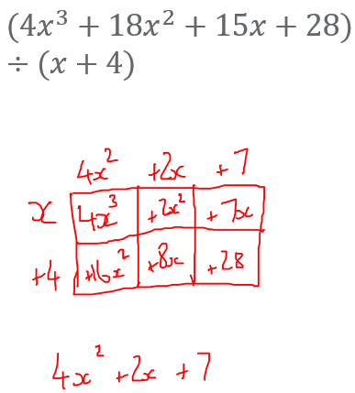
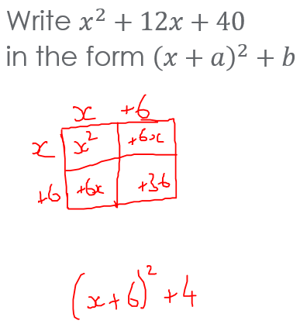
By exploiting the distributive law and area models of multiplication, we use the grid method where we can. Initially this is introduced through the multiplication of numbers. At this stage students may find the method more cumbersome than the long multiplication they learnt at Primary, this method, however, reduces the amount of information a student needs to hold in their head and is much easier to self-check; as a result, we will encourage all students to use this method. Crucially, it lays the groundwork for some complex algebraic procedures they will meet further down the line. As students progress through the curriculum this method will be used when expanding binomials and trinomials as well as when factorising linear and quadratic expressions. It will also be used when demonstrating how to complete the square. At A-Level this can also be extended to be used when dividing polynomials.
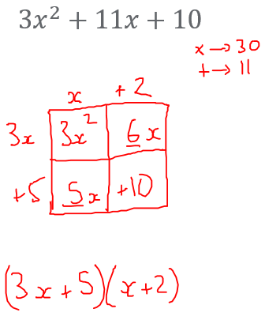
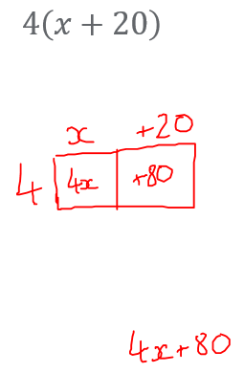
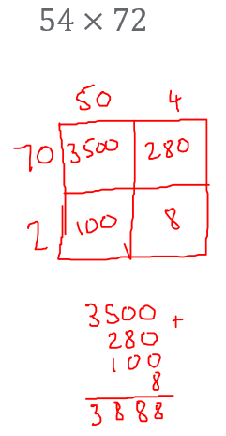

Key Words

Tier 3 Vocabulary
This vocabulary will be specific to maths and will need explicitly teaching to students.
Word | Definition
Binomial | An expression containing the sum of two terms
Quadratic | An expression in the form $ax^{2}+bx+c$ where $a≠0$
Piece-wise linear | A function made up of different straight lines joined together
Parabola | The curve made from plotting a quadratic function

Tier 2 Vocabulary
This vocabulary will not be specific to maths but may have a different meaning or usage in the maths classroom to what students are used to. These words will likely not need introducing to the students but the way they are used in a maths context may.
Word | Definition
Expanding | Multiplying expressions together to remove the brackets surrounding them
Plotting | Using coordinates to help create the shape of a curve
Sketching | A rough drawing of a graph containing its key features
Exponential | An expression in the form $a^{x}$
Reciprocal | An expression in the form $\frac{a}{x}$

Topic History and Hinterland

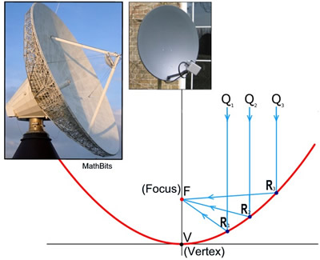
All satellite dishes are in the shape of a parabola as they have the special property of reflecting all signals to the same focus point. This can then be used to amplify signals by concentrating the information received into one point and thereby “boosting” the signal.

Possible Learning Sequence
This gives a suggestion of the order in which content could be introduced to students when they are being taught this unit. These are not given as a list of discrete lessons but more a logical order which could lead to the strongest learning outcomes. It is assumed that any pre-requisite knowledge needed for the content in this unit has been adequately covered, these will only cover the order of the new content being introduced. Appropriate AO2 and AO3 aims should interwoven throughout the lessons students have – this is only a list of the knowledge content.
Order | Learning Outcome
1 | Expand the product of two binomials
2 | Expand the product of more than two binomials
3 | Know the general shape and properties of a quadratic graph
4 | Plot quadratic graphs
5 | Use quadratic graphs to estimate values of x given values of y (and vice versa)
6 | Find solutions and approximations to problems in graphs in context including quadratic, piece-wise linear, exponential, and reciprocal graphs

Resources
Find below a list of resources specific to this topic and some websites known to be good sources of general questions. Resources chosen are ones which put the maths front and centre. They make sure that what children are attending to is as beneficial to their learning as possible. Examples of things that would not do this are codebreakers and treasure hunt where the task itself may distract from the mathematics being studied. Maths classrooms need not (and in fact should not) be devoid of fun, surprise and enjoyment but the maths being studied is complex and intriguing enough to be the fuel for this, we need not trick students into enjoying maths through any other route than the maths itself.
Resource | Sub-topic | Notes
P233-238 NCETM KS3 Guidance | Expanding brackets | Stretch, context
https://www.geogebra.org/m/uQJDjhAm | Graphic quadratics | Dynamical graphic software

Generic Websites
https://variationtheory.com/ - sequences of questions where one small part of a question will change each time which can be used to encourage students to find and predict patterns with the aim of better understanding the underlying structure of the mathematics.
https://ssddproblems.com/ - SSDD problems are a special type of problem based on the observation from Roher, Dedrick and Burgess (2014) that the correct solution to most mathematical problems involves two steps: identify the strategy needed to solve the problem, and then successfully carry out that strategy. These problems help students with that first step by showing questions with a similar surface but a different depth difference. This makes method selection an explicit skill students will be able to practice.
https://www.mathsgenie.co.uk/gcse.html - a selection of past GCSE questions and exam-style questions grouped by topic and broadly by grade.
https://corbettmaths.com/contents/ - questions grouped by topic containing mixed practice and typically some AO2 or AO3 style questions as well.
https://nrich.maths.org/ - a source of richer problem-solving questions. To be used cautiously!
https://www.cimt.org.uk/ - an old and hard to navigate website full of great resources.
https://www.exampro.co.uk/ - AQAs bank of KS3 and KS4 assessment questions. These are up to date and can be filtered by key stage, tier, AO1/2/3, calc or non-calc, curriculum area….
http://www.mrbartonmaths.com/teachers/rich-tasks/standards-units.html - Standards Units - a relatively small collection of some great tasks.
https://assets.publishing.service.gov.uk/government/uploads/system/uploads/attachment_data/file/1056795/KS3_NonStatutory_Guidance_Sept_2021_FINAL_NCETM.pdf - Guidance from the NCETM and DfE about resources to be used at KS3.
https://www.geogebra.org/materials?lang=en – A searchable database of pre-made and dynamic resources using GeoGebra (sometimes best to search for the topic and include the word GeoGebra in Google to find what you want)
https://mathigon.org/ - an online textbook full of dynamic examples and mathematical history

