

1

Maths Curriculum
Go-To Guide:
KS4
Unit: Circles and Angles
Topic: Circle Theorems
Creative Education Trust

Contents
Overview 3
NC Objectives 3
Summary 3
Where in the Curriculum 3
Past Curriculum Links 3
Upcoming Curriculum Links 3
Cross-Curricular Links 3
Topic Familiarisation 4
Questions 5
Mark Scheme 11
Examiners Notes (Where Available) 15
Possible Models and Tips 17
Key Words 18
Tier 3 Vocabulary 18
Tier 2 Vocabulary 18
Topic History and Hinterland 19
Possible Learning Sequence 20
Resources 21

Overview

NC Objectives
- Apply and prove the standard circle theorems concerning angles, radii, tangents and chords, and use them to prove related results.
Notes from AQA: “including angle subtended by an arc at the centre is equal to twice the angle subtended at any point on the circumference, angle subtended at the circumference by a semicircle is 90°, angles in the same segment are equal, opposite angles in a cyclic quadrilateral sum to 180°, tangent at any point on a circle is perpendicular to the radius at that point, tangents from an external point are equal in length, the perpendicular from the centre to a chord bisects the chord, alternate segment theorem.”

Summary
This topic covers all the circle theorems and corresponding knowledge around them. As well as knowing the theorems pupils will need to be able to lay out their reasoning clearly, justifying each step as they go and should also be able to prove the theorems.

Where in the Curriculum
This is in one of the last units in Y11 and only occurs at higher tier.

Past Curriculum Links
Pupils should have encountered circles and know the names of parts of the circle. Their practice at laying out reasoning problems with more accessible geometry will also be useful here.

Upcoming Curriculum Links
There are links to calculating the equation of a tangent to a circle.

Cross-Curricular Links

Topic Familiarisation
This is an exercise for teachers to complete before teaching a unit to familiarise them with both the pedagogical and subject knowledge necessary to delivery this topic effectively. Teachers should seek to ensure they can confidently answer all these questions and understand the “why” behind each one before teaching the first lesson of a unit. It’s important to note that the questions are not an exhaustive list of how something can be assessed. Instead, they give an indication as to some of the ways in which the content can appear and teaching, at the very least, needs to prepare pupils for these.
Structure:
- Questions
- Mark scheme
- Examiner’s report – where available
When completing the questions, it is important to do more than just find the correct answer. Ask yourself:
- What might my students struggle with?
- What gaps are there in my subject knowledge?
- What do I want a model answer to look like?
- How do I know what to do for each question? What are the clues?
- What do the examiner reports say are the main issues students have? How can I address these?
- What do the mark schemes look like? How can students achieve full or partial marks?
- What alternative methods are available? Will this affect how I model these processes?
- Are there links to other subjects? What chances do I have to make this explicit?
- What pre-requisite knowledge will my students need? How can I deliver this?

Questions
Q1.
(a) O is the centre of the circle.
Work out the size of angle a.
Not drawn accurately
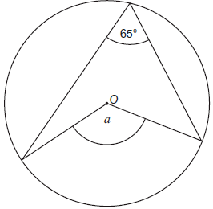
Circle your answer.
115° 130° 135° 295°
(1)
(b) Work out the size of angle b.
Not drawn accurately
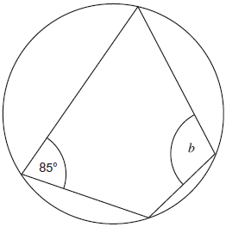
Circle your answer.
85° 90° 95° 115°
(1)
(c) ABCD are points on the circumference of a circle centre O.
Angle BCD = 130°
Angle ABC = 105°
Angle OBC = Angle ODC
Not drawn accurately
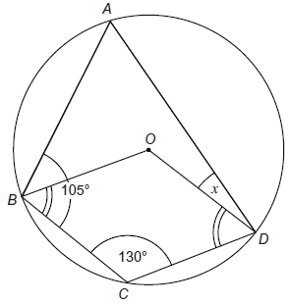
Work out the size of angle ADO, marked x on the diagram.
You must show your working which may be on the diagram.
(4)

_______________________________________________________________________
_______________________________________________________________________
_______________________________________________________________________
_______________________________________________________________________
_______________________________________________________________________
_______________________________________________________________________
_______________________________________________________________________
_______________________________________________________________________
_______________________________________________________________________
_______________________________________________________________________

(Total 6 marks)

Q2.
ABCD is a quadrilateral.
Not drawn accurately
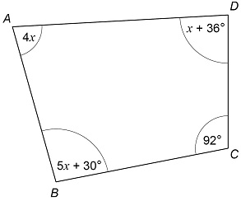
Prove that ABCD is not a cyclic quadrilateral.
_______________________________________________________________________
_______________________________________________________________________
_______________________________________________________________________
_______________________________________________________________________
_______________________________________________________________________
_______________________________________________________________________
_______________________________________________________________________
_______________________________________________________________________
_______________________________________________________________________
_______________________________________________________________________
_______________________________________________________________________
_______________________________________________________________________
(Total 4 marks)

Q3.
A, B and C are three points on the circumference of a circle, centre O.
BD and CD are tangents to the circle.
ABDC is a kite.
Angle BDC is x
Not drawn accurately
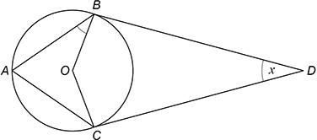
Prove that angle ABO is
_______________________________________________________________________
_______________________________________________________________________
_______________________________________________________________________
_______________________________________________________________________
_______________________________________________________________________
_______________________________________________________________________
_______________________________________________________________________
_______________________________________________________________________
_______________________________________________________________________
_______________________________________________________________________
_______________________________________________________________________
_______________________________________________________________________
(Total 4 marks)

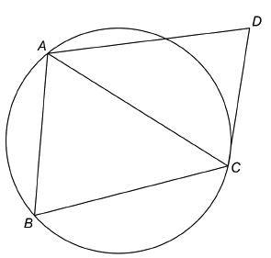
Q4.
A, B and C are points on a circle.
CD is a tangent.
Not drawn accurately

(a) Assume that triangle ABC is isosceles with AC = BC
Prove that AB is parallel to DC.
___________________________________________________________________
___________________________________________________________________
___________________________________________________________________
___________________________________________________________________
___________________________________________________________________
___________________________________________________________________
___________________________________________________________________
___________________________________________________________________
___________________________________________________________________
(4)
(b) In fact, triangle ABC is equilateral.
Tick the two boxes for the statements that must be correct.

 | AB is parallel to DC
 | AC bisects angle BCD
 | AC bisects angle BAD
(1)
(Total 5 marks)

Q5.

ABP and ADQ are tangents to the circle, centre O.
C lies on the circumference of the circle.
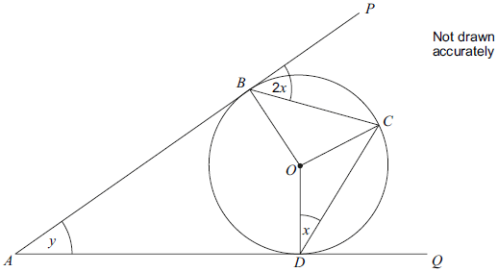
Prove that y = 2x
Give reasons for any statements you make.
_______________________________________________________________________
_______________________________________________________________________
_______________________________________________________________________
_______________________________________________________________________
_______________________________________________________________________
_______________________________________________________________________
_______________________________________________________________________
_______________________________________________________________________
_______________________________________________________________________
_______________________________________________________________________
_______________________________________________________________________
_______________________________________________________________________
_______________________________________________________________________
_______________________________________________________________________
(Total 6 marks)

Mark Scheme
Q1.
(a) 130
B1
(b) 95
B1
(c) BAD = 50 or
BOD (reflex) = 260
or ADC = 75
B1
BOD = 100
B1
OBC = 65 or ODC = 65
B1
10
B1
[6]
Q2.
Alternative method 1: works out the value of x using two different methods and shows they are different
Any one of
4x + 92 = 180
or
5x + 30 + x + 36 = 180
or 6x + 66 = 180
or
4x + x + 36 + 5x + 30 + 92 = 360
or 10x + 158 = 360
oe
M1
(x =) 22 with M1 seen
or
(x =) 19 with M1 seen
or
(x =) 20.2 with M1 seen
must be correct value for corresponding equation
A1
A different one of
4x + 92 = 180
or
5x + 30 + x + 36 = 180
or 6x + 66 = 180
or
4x + x + 36 + 5x + 30 + 92 = 360
or 10x + 158 = 360
oe
M1
Any two of
(x =) 22 with M1 seen
or (x =) 19 with M1 seen
or (x =) 20.2 with M1 seen
must be correct values for corresponding equations
and
should be equal
oe statement
A1
Alternative method 2: uses angle sum of quadrilateral to work out x and then shows opposite angles do not sum to 180°
4x + x + 36 + 5x + 30 + 92 = 360
or 10x + 158 = 360
oe
M1
(x =) 20.2 with M1 seen
A1
4 × their 20.2 + 92
or
5 × their 20.2 + 30 + their 20.2 + 36
oe
M1dep
4 × 20.2 + 92 = 172.8
oe
and should be 180
oe statement
or
5 × 20.2 + 30 + 20.2 + 36 = 187.2
oe
and should be 180
oe statement
A1

Other methods are also available

Q3.
Alternative method 1
OBD and OCD are right angles
and
BOC (obtuse) = 180 – x
may be on diagram
M1
BAC = 90 –
oe
may be on diagram
M1dep
BOC (reflex) = 180 + x
and
ABO + ACO = 360 – (90 – + 180 + x) or 90 –
oe 360 – 90 + – 180 – x
and
ABO = (90 – )
= 45 –
with M2 scored
A1
All reasons given
tangent meets the radius at 90°
angles in a quadrilateral add up to 360°
angle at the circumference is half the angle at the centre
angles around a point add to 360°
A1
Alternative method 2
OBD and OCD are right angles
and
BOC (obtuse) = 180 – x
may be on diagram
M1
BAC = 90 –
oe
may be on diagram
M1dep
BOC (reflex) = 180 + x
and
BAD = (90 – ) or 45 –
and
ABO = 180 – (45 – ) – (90 + )
= 45 –
with M2 scored
A1
All reasons given
tangent meets the radius at 90°
angles in a quadrilateral add up to 360°
angle at the circumference is half the angle at the centre
angles in a triangle add up to 180°
A1
Other methods are also available

Q4.
(a) Alternative method 1: shows that BAC = ACD and alternate angles
ACD = ABC
accept both with same letter on diagram
M1
ABC = BAC
accept both with same letter on diagram
M1
BAC = ACD
and alternate segment (theorem)
with M2 awarded
dep on M2
Other two correct reasons given with M3 awarded
e.g.
(base angles of) isosceles triangle and alternate angles
A1
Alternative method 2: shows that ABC + BCD = 180 and co-interior angles
ACD = ABC
accept both with same letter on diagram
M1
ABC = BAC
accept both with same letter on diagram
M1
BCD = 180 – (BAC + ABC) + ACD
and ABC + BCD = 180
and alternate segment (theorem)
with M2 awarded
oe
dep on M2
M1dep
Other two correct reasons given with M3 awarded
e.g.
(base angles of) isosceles triangle
and (co-)interior angles or allied angles
A1
Other methods are also available

(b)

 | AB is parallel to DC
 | AC bisects angle BCD
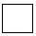 | AC bisects angle BAD
B1
[5]
Q5.

Join BD
Angle BDC = 2x
Alternate segment theorem
M1
Angle BDO = x
M1
Angle DBO = x
Isosceles triangle BOD
M1
Angle BOD = 180 − 2x
Angle sum of triangle BOD
M1
y = 360 − 90 − 90 − (180 − 2x)
y = 2x
Angle sum of quadrilateral ABOD
y = 2x clearly shown from simplification
A1
Must have at least two different reasons stated in the proof
B1ft
Alternative method 1
Angle OBC = 90 − 2x
Tangent-radius property
M1
Angle OCB = 90 − 2x
Isosceles Δ OBC
M1
Angle OCD = x
Isosceles Δ OCD
M1
Angle BCD = 90 – 2x + x
= 90 – x
hence
Angle BOD = 180 − 2x
Angle at centre = 2 × angle at circumference
M1
y = 360 − 90 − 90 − (180 − 2x)
y = 2x
Angle sum of quadrilateral ABOD
y = 2x clearly shown from simplification
A1
Must have at least two different reasons stated in the proof
B1ft
Alternative method 2
Angle OBC = 90 − 2x
Tangent-radius property
M1
Angle OCB = 90 − 2x
Isosceles Δ OBC
M1
Angle OCD = x
Isosceles Δ OCD
M1
Angle BCD = 90 − 2x + x
= 90 − x
hence
Angle BOD = 180 − 2x
Angle at centre = 2 × angle at circumference
M1
Angle BOD = 360 − 90 − 90 − y
= 180 − y
hence y = 2x
Angle sum of quadrilateral ABOD
y = 2x clearly shown from simplification
A1
Must have at least two different reasons stated in the proof
B1ft
Other methods are also available

Examiners Notes (Where Available)
Q1.
Parts (a) and (b) were quite well answered. Part (c) was not well answered. There was a lot of misuse of circle theorems. For example, angle BOD = 50° or 130°, or angle ADC = 105°.
Q2.
This question was a good discriminator, with a fair proportion of students on each mark. Over half of the students scored the first two marks, usually by equating the sum of the four angles to 360 and working out the value of x. Many lost the final two marks by substituting that value into the individual expressions, adding them, and showing, due to arithmetic errors, that the sum was not 360.
Students often thought that opposite angles in a cyclic quadrilateral are equal.
Q3.
This high demand question was beyond the ability of all but the most able students, demonstrated by the large proportion of non-attempts and zero marks awarded. For those who gained marks, the question further discriminated across the range of abilities at this high grade. Common basic errors included: choosing a value for x, incorrect notation for identifying angles, starting with angle ABO and trying to work backwards, incorrect recall of circle theorems or angle properties of quadrilaterals and triangles. Some students who gained three marks for a fully correct proof did not give any / all of the geometrical reasons required.
Q4.
Very few students scored more than 2 marks in part (a) with most working on the assumption that ABCD was a parallelogram. Those who made some progress often failed to give any reasons for their statements. Students should give a reason for each calculation or statement in geometric proof questions.
Less than a quarter of all students were successful in part (b). Many did not select the first statement, even though it had been given in part (a). Although they had been told to tick two boxes, a minority of students only ticked one.
Q5.

Some very good and successful attempts were seen, using the many different approaches that were possible. For the majority, however, it proved too challenging. Proof questions demand a rigorous approach with facts supported by reasons. Many students gave reasons that were neither supported by working nor relevant to a logical solution. A few students correctly used the alternate segment theorem within their solution, although many used it incorrectly, often stating that angle BOC = 2x. The most common error was to assume a symmetry of the diagram that did not exist, and thus deciding that all the angles at the base of triangles OCD and OBC must be x.

Possible Models and Tips
This section will give an overview of some models, layouts, metaphors, misconceptions or just general tips that could be used to help teach parts of this unit.

The One True Circle Theorem?
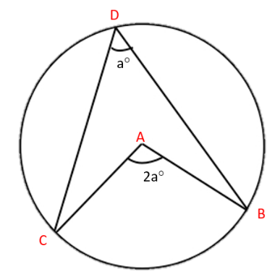
With so many theorems to teach it’s helpful connecting them together where possible. It could be worth starting with the fact that the angle subtended from any arc to the centre is twice the angle it makes when subtended to the circumference. From here it can be seen that angles subtended from the same arc to the circumference will be equal since the angle at the centre won’t change. If you arrange the points C, A and B, into one line (keeping A at the centre) then the angle formed is 180$°$, from here you can see that the angle created by subtending the diameter of a semi-circle to the circumference must therefore be 90$°$. You can also think of two angles being created at the centre, in this case 2a and 360-2a. If you also subtended the angle from BC to the other side of the circumference you would now have 2 angles that add up to half of 360$°$ and you have the result that opposite angles in a cycle quadrilateral sum to 180$°$

Use Non-Examples
It is near impossible to fully grasp these theorems from just one sentence or one example. Whilst multiple examples will be important using non-examples and boundary cases will be just as useful.

Use Dynamic Software
Using software like GeoGebra to highlight multiple cases in an instant and showing to the pupils what can and cannot change to still make the theorem hold or not has the opportunity to be very powerful

Interweave
Learning one theorem is not the tricky part of this topic. Each is easily learnt and applied if in isolation. The difficulty arises when there are multiple theorems to choose from and no obvious clue in the given diagram as to which will be needed. Being sure to interleave the theorems as they are introducing to pupils is vital not just for their memory but for their appreciation of the sorts of questions they will be asked in their exam.

Reasoning
It is likely that students will have to write down their reasons for different steps so just knowing what results the theorems give aren’t enough. There needs to be plenty of time in lessons for students to practice writing and recalling the precise reasons that the theorems are true. They need to be familiar and comfortable with the language used in this topic.

Generalising
Do not always use numerical values in the problems students are exposed to. By using unknowns you are preparing them not only for more scenarios and helping them to generalise but questions like these will be useful when proving the theorems.

Key Words

Tier 3 Vocabulary
This vocabulary will be specific to maths and will need explicitly teaching to students.
Word | Definition
Cyclic quadrilateral | A 4-sided shape whose vertices could all lie on the circumference of a circle
Subtend | To form an angle at a point from the ends of a line or arc

Tier 2 Vocabulary
This vocabulary will not be specific to maths but may have a different meaning or usage in the maths classroom to what students are used to. These words will likely not need introducing to the students but the way they are used in a maths context may.
Word | Definition
Tangent | Maths – a straight line that only touches a circle once  English – a completely different line of thought or action
Chord | Maths – a straight line connected two points around the circumference of a circle  Music – a group of (typically three or more) notes sounded together, as a basis of harmony
Equidistant | The same distance
Segment | General – a part of which something has been divided  Maths – the area created in a circle between a chord and its circumference  Biology – each of the series of similar anatomical units of which the body and appendages of some animals are composed, such as the visible rings of an earthworm's body  English – the smallest distinct part of a spoken utterance, especially with regard to vowel and consonant sounds rather than stress or intonation.
Bisect | General – to divide into two parts  Maths – to divide perfectly in half
Perpendicular | At right angles to a given
Radius  Radii (pl) | Maths - a straight line or lines from the centre of a circle to its circumference  Biology - the thicker and shorter of the two bones in the human forearm  DT - give a rounded form to (a corner or edge). "She carefully radiused all the sharp edges and corners"

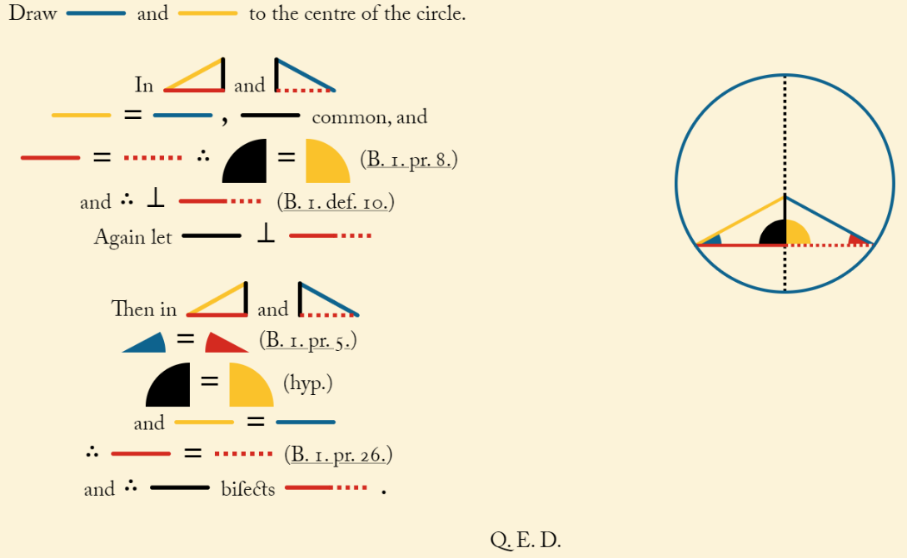
Topic History and Hinterland
Thales of Miletus, often referred to as the Father of Science, was born in what today is Turkey but he lived and worked in Ancient Greece around 600BC. He is the earliest known person to have a mathematical discovery named after him and the first known to work with circles and circle theorems.
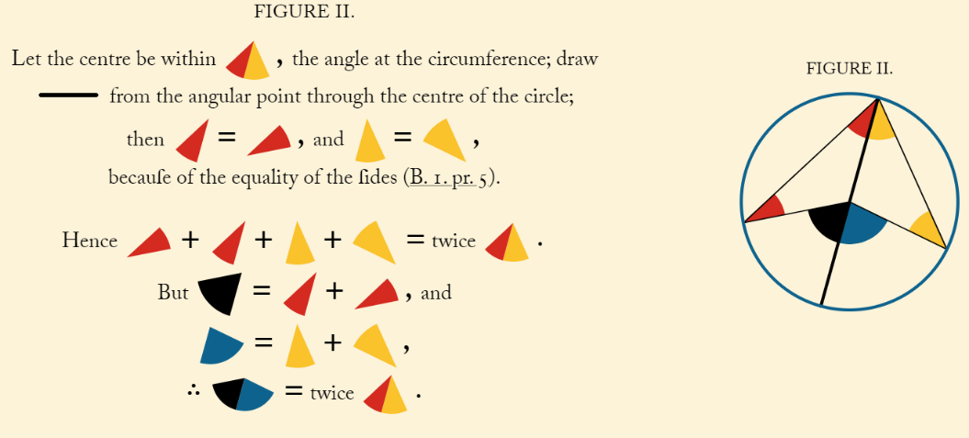
In 300BC Euclid, another ancient Greek, who most likely spent his career working in Alexandria in Egypt, when it was the greatest city in the world. He is famous for writing his book The Elements which started to chronicle mathematical ideas in a structured and logical manner. To this day that book is the second most printed book ever (after the bible). A lot of the maths that has been taught to students for the last 2000 years has used this book as a guide or textbook. Whilst some of the maths and notation we study is relatively new, some of the content has been taught to children across the world for thousands of years.
In the 1800s Oliver Byrne, an English mathematician, worked on producing a coloured version of the book. This is where the pictures here come from.

Possible Learning Sequence
This gives a suggestion of the order in which content could be introduced to students when they are being taught this unit. These are not given as a list of discrete lessons but more a logical order which could lead to the strongest learning outcomes. It is assumed that any pre-requisite knowledge needed for the content in this unit has been adequately covered, these will only cover the order of the new content being introduced. Appropriate AO2 and AO3 aims should interwoven throughout the lessons students have – this is only a list of the knowledge content.
Order | Learning Outcome
1 | Angles at the centre are twice those at the circumference/Angles subtended from the same arc are equal
2 | The angle in a semi-circle is 90$°$/Opposite angles in a cyclic quadrilateral sum to 180$°$
3 | The perpendicular from the centre to a chord bisect that chord/Alternate segment theorem
4 | The tangents from a point to the circle are the same distance/The tangent to a any point on the circle is perpendicular to the radius at that point
5 | Complex reasoning problems
6 | Proving the theorems

Resources
Find below a list of resources specific to this topic and some websites known to be good sources of general questions. Resources chosen are ones which put the maths front and centre. They make sure that what children are attending to is as beneficial to their learning as possible. Examples of things that would not do this are codebreakers and treasure hunt where the task itself may distract from the mathematics being studied. Maths classrooms need not (and in fact should not) be devoid of fun, surprise and enjoyment but the maths being studied is complex and intriguing enough to be the fuel for this, we need not trick students into enjoying maths through any other route than the maths itself.
Resource | Sub-topic | Notes
GeoGebra Link | Circle theorems | Dynamic software
https://www.c82.net/euclid/book3/ | Circle theorem proofs | A link to the Oliver Byrne’s coloured version of Euclid’s the Elements

Generic Websites
https://variationtheory.com/ - sequences of questions where one small part of a question will change each time which can be used to encourage students to find and predict patterns with the aim of better understanding the underlying structure of the mathematics.
https://ssddproblems.com/ - SSDD problems are a special type of problem based on the observation from Roher, Dedrick and Burgess (2014) that the correct solution to most mathematical problems involves two steps: identify the strategy needed to solve the problem, and then successfully carry out that strategy. These problems help students with that first step by showing questions with a similar surface but a different depth difference. This makes method selection an explicit skill students will be able to practice.
https://www.mathsgenie.co.uk/gcse.html - a selection of past GCSE questions and exam-style questions grouped by topic and broadly by grade.
https://corbettmaths.com/contents/ - questions grouped by topic containing mixed practice and typically some AO2 or AO3 style questions as well.
https://nrich.maths.org/ - a source of richer problem-solving questions. To be used cautiously!
https://www.cimt.org.uk/ - an old and hard to navigate website full of great resources.
https://www.exampro.co.uk/ - AQAs bank of KS3 and KS4 assessment questions. These are up to date and can be filtered by key stage, tier, AO1/2/3, calc or non-calc, curriculum area….
http://www.mrbartonmaths.com/teachers/rich-tasks/standards-units.html - Standards Units - a relatively small collection of some great tasks.
https://assets.publishing.service.gov.uk/government/uploads/system/uploads/attachment_data/file/1056795/KS3_NonStatutory_Guidance_Sept_2021_FINAL_NCETM.pdf - Guidance from the NCETM and DfE about resources to be used at KS3.
https://www.geogebra.org/materials?lang=en – A searchable database of pre-made and dynamic resources using GeoGebra (sometimes best to search for the topic and include the word GeoGebra in Google to find what you want)
https://mathigon.org/ - an online textbook full of dynamic examples and mathematical history

